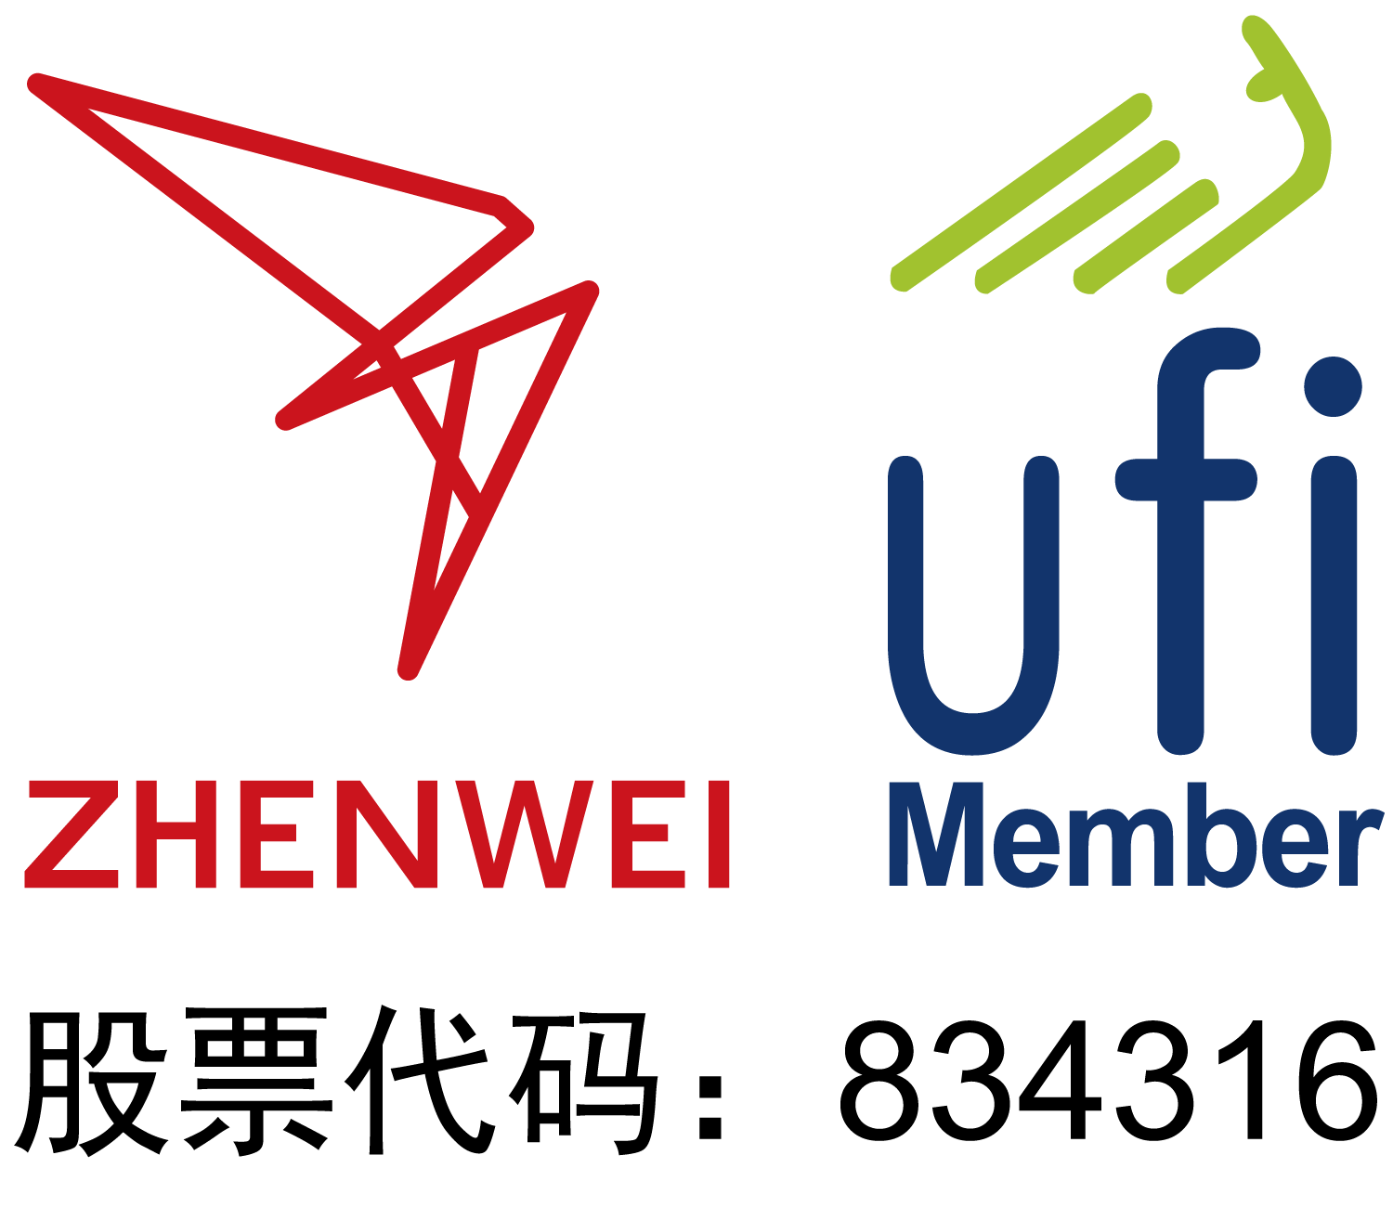
INVITATION

To: From:


The 17th Shanghai International Petrochemical Technology and Equipment Exhibition

June 5-7, 2025
Shanghai New International Expo Center
https://sh.cippe.com.cn/en/
Sponsors
Zhenwei International Exhibition Group
Beijing Zhenwei Exhibition Co., Ltd.
China Petroleum & Petrochemical Equipment Industry Association
Concurrent Exhibitions:
The 17th Shanghai International Petrochemical Automation & Instruments Exhibition
The 17th Shanghai International Chemical Technology & Equipment Fair
The 17th Shanghai International Explosion Protection and Electric Technology & Equipment Exhibition
The 17th Shanghai International Petrochemical Safety Production and Protection Products Exhibition
Shanghai International Plastics and Rubbers Exhibition
Shanghai International Medical Chemical Exhibition

Exhibition Profile
cippe is an internationally renowned event brand in the petroleum and petrochemical industry, and an UFI approved event.
cippe Shanghai has been held successfully for 16 years. The 17th Shanghai International Petrochemical Technology and Equipment Exhibition (cippe2025 Shanghai), with an exhibition space around 70,000 square meters, is expected to convene about 1,000 exhibitors & 100,000 person-time visitors from 52 countries and regions including USA, Italy, Russia, Germany, France, Japan, Singapore, etc.
The exhibition is expected to welcome leading enterprises such as Schlumberger, GE, Cummins, Caterpillar, Sulzer, NETZSCH, Piller, HERMETIC, Curtiss Wright, IIR, Five Proabd, STEAMLOC, Dellmeco, Yonei, Hakuto, KUMWOO, ASUNG, Shanghai Shenkai, Jereh, Kosun, Aerospace Petrochemical, HISENSE, Wuxi Kipor, BARTEC, Changcheng Pump, Luxi Chemical, Jiangsu Saideli, Jintongling, Liaohe Pharmaceutical Equipment, Hangzhou Feier Filtering, Kaishan Group, Shanghai Senon, Myande, Zhongteng Environmental Protection, Yixing Grand, Tianjin KuaiTurbo, Youfumi Group, Weidouli Valves, Anhui Shengtang, Jiangsu Xinshijie Pump, Fanqun Drying Equipment, Meluck, CIGU, etc.
And cippe Shanghai will invite professional visitors from associations and enterprises, such as China Chlor-Alkali Industry Association, China Chemical Enterprise Management Association, Shanghai Chemical Industry Association, Shanghai Chemical Industry (China) Council, Shanghai Coatings and Dyestuff Trade Association, Europump, PPMA, Shell, Total, ConocoPhillips, Statoil, Aramco Asia, SK, Fluor, BASF, Yanchang Petroleum, Shengli Oilfield, Shanghai Petrochemical, Sinopec Zhenhai Refining & Chemical, COSL, Wison, Qilu Petrochemical, Offshore Oil Engineering Co., Ltd. and others to participate in.
Who Should Exhibit
- Petrochemical Plant Device & Equipment
- Refinery Technology and Equipment
- DCS, PLC Control System
- Petrochemical Process and Technology
- Fluid Machinery and Process Industry Technology and Equipment
- Industrial Explosion-proof Products
- Storage, Transportation, Pressure Vessel and Packaging Technology
- Automation Technology & Equipment, Instrumentation
- Sealing Equipment and Accessories
- Petrochemical Products and Advanced Materials
- Technology and Equipment for Scientific Research and Laboratory in Petroleum & Petrochemical Industry
- Communication and Information System
- Electrical & Electronic Equipment, Cable and Wire
- Examination & Repair, Maintenance and Management of Sales System and Facilities (Gas Station Equipment)
- Refinery Process Technology
- Fuel and Lubrication Technology and Equipment
- Heat Transfer, Refrigeration, Ventilation Equipment
- Environmental Protection, Safety, Energy-saving Equipment
- Separation, Drying, Crushing, Mixing Equipment
- Power Machinery including Generator Set
- Oil & Gas Recovery Technology and Equipment
- Fire and Alarm Equipment, Articles for Industrial Safety and Labor Protection
- Boiler Pressure Vessel Equipment
- Technology and Equipment for Industrial rinsing and Anti-corrosion
- Technology and Equipment for Oil and Gas Pipeline Engineering
- Auxiliary and Other Equipment
- Extraction Purification, Evaporation Crystallization
- Process Control System and Software
- Petrochemical Emergency & Safety Equipment
Exhibition Schedule
Registration & Set up: June 3-4, 2025
Exhibition & Trade: June 5-7, 2025
Closure & Dismantling: 14:00pm, June 7, 2025
Venue: Shanghai New International Expo Center
Technical Seminar
The organizer is honored to assist exhibitors in host technical seminars during the exhibition. The topic, content and speakers of each technical seminar is up to the exhibitors. Exhibitor could invite target customers to attend, with no more than 80 attendees of each session, due to the capacity of conference rooms. Each seminar lasts one hour with a fee of CNY 15,000, which covers the space of the seminar and relevant facilities. Please send your topic, content introduction and name of presenter to the organizer before the deadline by May 15, 2025.
Exhibiting Costs
- Booth Cost: This exhibition will provide International exhibitors with two options:
- Shell Scheme Booth:
Price: CNY 30,000/9sqm; Regular size: 3m×3m.
This option includes back & inside walls, carpet, fascia board, one consulting table, two chairs, two lights and one power socket (220V, 5A).
- Raw Space:
Price: CNY 3,200/sqm (Minimum 36sqm)
Empty exhibition space for exhibitor to customize booth design and construction. The exhibitors shall not choose contractors not designated by the organizer to design or construct their booths.
- Additional Exhibitor Service (not required):
Price: CNY 1,200/person (includes lunches, beverages, gifts, etc.)
- Exhibition Catalogue Advertisement
Front Cover | CNY 25,000 | Inside Front Cover | CNY 18,000
Head Page | CNY 18,000 | Back Cover | CNY 20,000
Inside Back Cover | CNY 15,000 | Colored Inside Page | CNY 8,000
- Sponsorship Opportunities:
For more sponsorship opportunities, such as hanging banners, entrance badges and others, please contact the organizing committee.
Exhibitor Manual: The Exhibitor Manual (including information concerned with the schedule, hotel, freight forwarding, transportation, stand construction, etc.) will be uploaded to website two months before the exhibition.

Organizer: Beijing Zhenwei Exhibition Co., Ltd.
Add: Zhenwei Exhibition Building, Building III13, International Enterprise Avenue, Yard 1, Jinghai 5th Road, Tongzhou District, Beijing
Tel: +86-10-
E-mail: Contact:
cippe2025 Shanghai Application / Contract
The 17th Shanghai International Petrochemical Technology and Equipment Exhibition
Date: June 5-7, 2025 Venue: Shanghai New International Expo Center
Please fill out the form below and send it back to the organizer via fax or email. All details will be used for contact and booth headboard purposes.
Company Name:(Chinese)
(English) Address: Postal/Zip code:
Contact Person (Mr. /Ms): Position:
Tel: Fax: Website: E-mail:
Main products/exhibits:
Exhibition Mode and Cost
- Space with shell scheme: sqm (CNY30,000/9sqm)
Booth No.: Fee:
Raw space: sqm (CNY3,200/sqm, minimum 36sqm)
Booth No.: Fee:
- Catalogue Advertisement:
□ Front Cover CNY25,000 □ Inside Front Cover CNY 18,000 □ Head Page CNY18,000
□ Back Cover CNY20,000 □ Inside Back Cover CNY15,000 □ Colored Inside Page CNY8,000
- Sponsorship:
□ Visitor Ticket CNY 50,000/50,000piece □ Handbag CNY 60,000/20,000pieces
□ Lanyard (Exclusive) CNY60,000/30,000pieces □ Location Mark on Floor Plan CNY30,000
- Technical Seminar: Session(s) (CNY15,000/session), Fee:
- Additional Exhibitor Service (CNY1,200/person, including lunches, beverages, gifts, etc.):
Total: Person(s), Fee:
★Payment Date:
★Additional Notes: 1. Please remit the total participation fee to the account appointed by the organizer within 10 working days upon receipt of the confirmation letter; 2. Booking received without this deposit will not be confirmed.
Zhenwei International Exhibition Group  Beijing Zhenwei Exhibition Co., Ltd.  Tel: Fax:  Mobile:  E-mail: Contact: | Company Name:  Signature & Stamp:

cippe2025 Shanghai Targeted Buyers Programme
Exhibitor Name
Website
Company Profile, Main Products & Technology
Products & Technology to be Showcased (better attach with pic.)
What kind of companies you are keenly interested in meeting at cippe2025 Shanghai?
Please name some companies you haven’t established business relations but hope to meet at cippe2025 Shanghai.
Please name some companies you are already in cooperation with and hope to meet at cippe2025 Shanghai. | Company | Contact | Tel / Mobile
Note: If the companies you would like to meet are giants like CNPC, SINOPEC, etc. Please name the branch name, departments or main business.

